Types of Metrical Feet

Types of Metrical Feet
# Source: Chatgpt (GPT-4-turbo) at [8/3/2025]
A metrical foot is the basic unit of rhythm in a line of poetry, made up of a specific combination of stressed (—) and unstressed (◡) syllables.
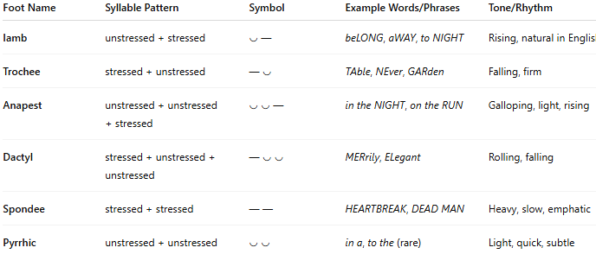
Foot Name | Syllable Pattern | Symbol | Example Words/Phrases | Tone/Rhythm
Iamb | unstressed + stressed | ◡ — | beLONG, aWAY, to NIGHT | Rising, natural in English
Trochee | stressed + unstressed | — ◡ | TAble, NEver, GARden | Falling, firm
Anapest | unstressed + unstressed + stressed | ◡ ◡ — | in the NIGHT, on the RUN | Galloping, light, rising
Dactyl | stressed + unstressed + unstressed | — ◡ ◡ | MERrily, ELegant | Rolling, falling
Spondee | stressed + stressed | — — | HEARTBREAK, DEAD MAN | Heavy, slow, emphatic
Pyrrhic | unstressed + unstressed | ◡ ◡ | in a, to the (rare) | Light, quick, subtle

🔹 Visual Summary:
# Source: Chatgpt (GPT-4-turbo) at [8/3/2025]
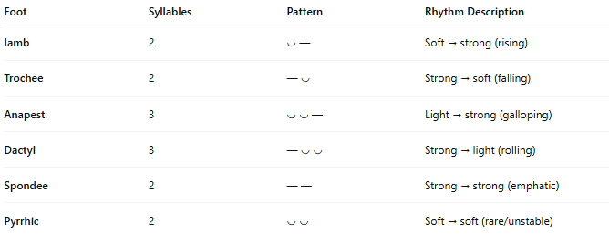
Foot | Syllables | Pattern | Rhythm Description
Iamb | 2 | ◡ — | Soft → strong (rising)
Trochee | 2 | — ◡ | Strong → soft (falling)
Anapest | 3 | ◡ ◡ — | Light → strong (galloping)
Dactyl | 3 | — ◡ ◡ | Strong → light (rolling)
Spondee | 2 | — — | Strong → strong (emphatic)
Pyrrhic | 2 | ◡ ◡ | Soft → soft (rare/unstable)

🔹 Notes:
# Source: Chatgpt (GPT-4-turbo) at [8/3/2025]
- Iambs and trochees are the most common in English.
- Anapests and dactyls are often used in more lyrical or dramatic forms.
- Spondees and pyrrhics rarely dominate a whole line; they usually appear as substitutions within larger meters.

